**The Need to Employ Virtual Reality to Enhance Earthquake-Evacuation Simulation**

Shiyi Liu

Department of Math, Science, and Technology, Teachers College, Columbia University

MSTU 5015 Research/Programming of Serious Games

Professor Joey Lee

## **The Need to Employ Virtual Reality to Enhance Earthquake-Evacuation Simulation**

In January 2010, a major earthquake of magnitude 7.0 struck Haiti, causing nearly 220,000 deaths (Patrick, 2011). According to the World Health Organization (WHO), earthquakes killed approximately 750,000 people globally from 1998 to 2017, more than any other type of natural disaster (WHO, 2017). Thus, education in earthquake safety is crucial to society.

To reduce seismic damage and better understand earthquakes, scientists employ various methods to simulate earthquake evacuation emergencies. Previous simulations include self-rescue practices, such as ShakeOut drills (Perry et al., 2008), which are common methods of earthquake safety social education. In 2008, for example, over 5 million people signed up to participate in the first ShakeOut drill in California, USA (Vinnell et al., 2020). Researchers also use 3D software to create and analyze earthquake models. Although these earlier methods are commonly used in earthquake safety training and research, they simulate only certain aspects of the earth shock emergency. The ShakeOut drills relied primarily on imagination and scripts, while 3D software could generate results only on computers. Thus, new technology, such as extended reality (XR) systems, needs to be introduced in this area to improve earthquake simulation by incorporating a sense of physical presence.

XR denotes all combined real-and-virtual situations and human-machine interactions produced by computer innovation and wearables (Fast-Berglund et al., 2018). In XR systems, human perceptions are no longer restricted to the real world. As there are only a few examples of research on the use of augmented reality (AR), mixed reality (MR), or niche XR technologies (e.g., brain-computer interfaces) for seismic imitation, this paper will only consider virtual reality (VR), which can be broadly defined as using artificial sensory stimulation to induce targeted behavior in an organism without them noticing (LaValle, 2020).

Many of the existing VR earthquake simulations were designed for earthquake evacuation drills. For instance, Li et al. (2017) provided an earthquake simulation approach based upon custom-grade VR technologies for earthquake safety training. The outcome demonstrated that using VR for indoor seismic evacuation training is more effective than traditional training methods, such as reading a manual or watching a video. Due to the unique affordance of VR, more elements of how VR enhances earthquake imitation merit evaluation. Therefore, this paper explains how VR could enhance earthquake evacuation simulation and explores its limitations.

### **VR Earthquake Simulation Benefits Different Groups**

As fatal natural disasters, earthquakes not only threaten human well-being but also influence society economically and socially (Snieder et al., 1997). Violence ground motion may not only cause severe damage on buildings and infrastructure but also heavily influence transportation and communication. Therefore, seismic damage mitigation requires the cooperation of various social groups (Satriano et al., 2011) including engineers, scientists, ordinary people, and insurers.

In order to reduce earthquake damage, distinct groups of people continually run earthquake simulations for different purposes. For instance, in past research, public schools are likely to participate in the ShakeOut Drills by following manual scripts to train students’ evacuation skills, whereas engineers are likely to run simulations by using 3D software to predict earthquake damage. Earthquake simulation have thus become important, and its enhancement becomes a need. Figure 1 illustrates the possible gain cause by using VR for earthquake simulation.

**Figure 1**

*How Diverse Groups Could Benefit from VR Earthquake Simulation.*

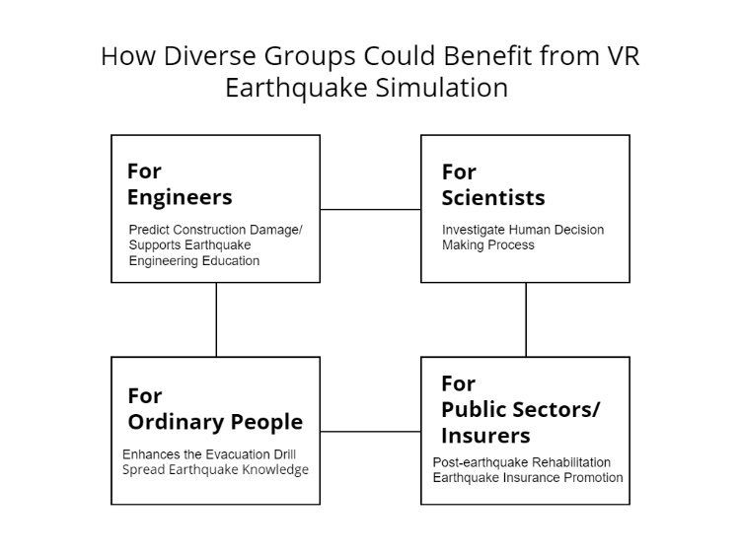

#### **Ordinary People’s Participation in Virtual Drills**

Traditionally, earthquake simulations and drills have been introduced as the standard types of earthquake preparedness program, not only to disseminate earthquake knowledge but also to help people plan for and survive a major earthquake. They are also broadly used for testing and training in local emergency response plans (Simpson, 2002). In a notable example, over 29 million people worldwide were registered in the 2020 Great ShakeOut Earthquake Drill (Great ShakeOut Earthquake Drills, 2021). According to the data, most of the participants were from the US. K-12 schools, higher education institutions, and government agencies made up a large proportion of the participants, while other organizations, such as business groups and nonprofit organizations, were also encouraged to join. The “Drop, Cover, and Hold On” strategy is therefore commonly acquired by the general public in the US. Johnson et al. (2016) evaluated the effectiveness of the ShakeOut drills in two Washington state school districts and concluded that students were able to maintain a high level of preparedness for earthquakes with the help of ShakeOut drills. In this respect, organizing earthquake drills in earthquake-prone zones enhances the evacuation process to improve evacuee safety.

Even though earthquake evacuation drills for risk reduction have been widely adopted globally, limitations persist that merit consideration. First, the participants may not learn the detailed tasks of the evacuation procedure due to the absence of individual feedback (Gwynne et al., 2019). Second, owing to legal and ethical constraints that forbid the creation of disaster scenes in real-world scenarios (Zhu & Li, 2021), simulated earthquake training does not fully represent earthquakes in real life. Moreover, as a large number of drills lack authorized third-party scrutiny (Gwynne et al., 2019), the participants may not always take such exercises seriously (Sukirman et al., 2019). Without being instructed and examined, participants may act sluggish because of the lack of post-evacuation individual feedback. Also, according to Yang et al. (2011), people behave significantly differently when facing earth shocks in real life than when engaging in exercises that mimic them. These combined limitations may reduce the effectiveness of the drill.

Thus, to enhance earthquake evacuation drills, VR technologies are introduced to shrink the gap between traditional evacuation drills and real-world natural disasters. The qualities of VR make it a perfect tool for conducting tests that are either too dangerous or too costly in the physical world (Akinola et al., 2020; Shudayfat et al., 2012), allowing participants to experience scenarios such as being hit by a flying object during a virtual drill. Several researchers have demonstrated the potential of using VR for evacuation training. For instance, Li et al. (2017) designed 12 indoor VR scenes to test the effectiveness of earthquake emergency safety training methods. The methods included participating in immersive virtual drills, watching educational videos, reading earthquake manuals, and not receiving training. The results indicate that people trained in VR not only gain more danger-avoidance knowledge but also remember it longer. Another study on using VR earthquake simulators to conduct failure-enhanced evacuation training shows that VR has the potential to train people to evacuate swiftly (Mitsuhara et al., 2019). The researchers forced the participants to fail the first training in VR for the purpose of reflection enhancement. Then they conducted a second training to evaluate the training outcome. As it is impossible to design a failure situation that may cause death or injury in the real world, the use of VR becomes essential. All these experiments revealed the effectiveness of VR-based earthquake drills for individual seismic safety training.

Beyond evacuation training, the edutainment aspect of the VR earthquake simulation also helped to disseminate earthquake knowledge for ordinary people. One example is the “Earthquake Simulator VR,” a VR earthquake simulation designed by Lindero Edutainment (Oculus, 2018). This is a published game designed for home-based VR equipment and could be easily accessed by individuals. In it, people are able to acquire earthquake safety knowledge immersive. Meanwhile, advanced versions of VR earthquake simulation motion platforms exist for edutainment purpose. A company called Pulevr developed a VR motion platform with a capacity of five people that displays VR earthquake scenes and mimics their seismic movement (Pulevr., nd). By utilizing equipment like this, people could experience ground motion safely. With the help of these new inventions, the general public is more likely to be interested in seismology and learn earthquake safety skills.

#### **Scientists Conduct Experiments Through Virtual Drills**

Scientists also benefit from the development of VR emergency simulation, which allows them to investigate the human decision-making process more precisely. This is an important area of study primarily because understanding how people may respond in an emergency enables scientists to develop earthquake evacuation guidelines accordingly. Peek-Asa et al. (1998) revealed that the causes of earthquake injuries are fairly complex, including both environmental and behavioral factors. Hence, novel studies on human response during real-world crises become significant.

Although the importance of investigating how people make decisions during an earthquake has been recognized, there is, unfortunately, no confirmed answer to the question. Most previous research has been restricted by the unpredictability of the disaster so that scientists could only gather quantitative data based on their observations of simulated drills (Liu et al., 2016). While those drills could effectively help the participants to learn earthquake safety skills, drills without actual danger are still insufficient for evaluating human behavior. This is because drill participants are unlikely to experience real escape panic and are able to behave calmly (Liu et al., 2016). Another common approach to collecting decision data, as in the study of Goltz et al. (2020), is through post-earthquake surveys after a real disaster. However, such data may lessen the credibility of the report due to the recall bias inherent in unreliable human memory. Thus, an alternative approach is needed.

Compared to previous methods, the development of virtual environments will give scientists opportunities to conduct research in a simulated earthquake with a much more apparent presence. Research has shown that using VR induces emotions and behaviors similar to those in the real world. For example, Feng et al. (2020) used verbal protocol analysis (VPA) as a cognitive analysis tool to investigate human decision-making in virtual earthquake drills to demonstrate the feasibility of this approach. With the help of VR, the gap for data credibility was reduced between real-world experience and the mimic drill. Thus, the think-aloud method in a user-immersed 3D virtual environment is likely to become a better way of gathering information during earthquake evacuation.

#### **Engineers Educated via Virtual Drills**

For engineers, VR improves the simulation of construction damage. This approach could not only help students to study earthquake engineering in a more intuitive way but also potentially refine seismic safety standards. Earthquake engineering is a relatively young discipline with a number of well-established concepts and procedures for constructional earthquake damage mitigation (Villaverde, 2009). Traditionally, earthquake engineers used mathematical and physical calculations to predict damage to buildings. Notwithstanding the effectiveness of this method, the knowledge itself is so abstract that might give students a hard time to understand. Hence a new method is needed that is not only precise enough but also sufficiently intuitive to simulate building damage due to earthquakes.

With recent advances in VR technology, seismic hazard assessment could be visualized even without physical experiments. According to LaValle (2020), VR provides a chance to visualize geometric relationships with difficult-to-understand concepts or details. VR offers Setareh et al. (2005) found that immersive VR applications could be employed to analyze building structures under various environmental conditions, and Xu et al. (2008) further explored this finding. Their experiment used VR as a simulation display platform to show building damage in an urban area during an earthquake. In a recent study, Sinha et al. (2012) created a 3D virtual environment for the live demonstration of an earthquake disaster. The motion of objects, light effects, and auditory elements were all taken into consideration, demonstrating VR’s ability to not only directly copy the physical environment but also bring participants into the mimic reality world. This would allow weak parts of a structure to be detected prior to its construction and seismic safety standards to be subsequently refined. The examples above confirm that VR is a suitable tool for earthquake damage simulation since it makes the simulation more intuitive and engaging.

With VR confirmed as an appropriate platform for mimicking seismic hazard, practical uses of the approach have emerged. For instance, Hutchinson et al. (2005) created a hybrid reality environment that allowed students to observe earthquake-associated damage in a sample building and to manipulate the data and model. The learning outcome of this experiment supported the plausibility of using the hybrid reality method for earthquake engineering education. That conclusion was supported by Setareh et al. (2005), who applied VR in building-science education. In all the studies mentioned in this section, earthquake simulations are generated in VR based on information on relevant properties and rigorous adherence to the laws of physics, supporting the conclusion that VR, with its ability to mimic the real world structures, is a great tool for earthquake engineering education.

#### **Public Sector/Insurers Benefited from VR Earthquake Simulation**

In addition to pre-earthquake preparation, VR also supports post-earthquake rehabilitation to reduce seismically induced damage. Insurance companies have used VR to generate knowledge of earthquake hazards and have subsequently improved the sale of their earthquake-related products to reduce post-earthquake costs. For example, due to the low penetration rate of earthquake insurance coverage in California (Woo, 2010), Saritasa LLC (2019) created a VR earthquake experience for iHeartMedia to promote earthquake insurance at Wango Tango (a large music festival in Southern California). As Southern California experiences about 10,000 earthquakes each year (United States Geological Survey [USGS], n.d.), such forward-looking action is essential.

Moreover, the public sector benefits from VR by immersively gaining post-earthquake rescue and reconstruction knowledge. Earthquake danger comprises two parts: primary earthquake hazards (ground shaking) and secondary hazards (earthquake-induced tsunamis, fires, etc.). In urban areas, post-earthquake fire hazards can be worse than the earthquake itself, so training for post-earthquake fire evacuation is as important as training for earthquake evacuation. Lu et al. (2020) provided a scientific basis for the development of post-earthquake fire rescue scenarios in VR for fire-rescue training, so future applications for post-earthquake fire rescue training could be developed based on this research. Also, as VR provides a basis for remote discussion among engineering teams, it contributes to managing the post-earthquake reconstruction plan, identifying engineers’ needs, visualizing information, and simulating the results of reconstruction (García et al., 2020).

### **Limitation & Future Research**

VR, with its unique affordance, provides people with an opportunity to build up their own virtual space. Various groups of specialists can use such a space to study and mitigate earthquake hazards better. However, limitations exist since this technology remains at an early stage and is restricted by human factors. All of the current designs of virtual earthquake evacuation drills do not provide any haptic feedback. Thus, although the visual feedback provided by VR could be extremely realistic, it is still hard for the participants to be truly immersive because the ground shaking elements of an earthquake are missing. Another issue that a VR designer must take into consideration is to reduce the motion sickness associated with self-motion experienced in the absence of real physical displacement (Lovreglio et al., 2018). Suali et al. (2020) investigated virtual earthquake participants and shows that various types of cybersickness such as headache, eyestrain, and nausea, may occur during the VR experience. Cybersickness could possibly influence the VR experience and thus, made the design purpose unable to be achieved.

Future research should, therefore, consider haptic feedback and motion sickness. One reference for integrating haptic feedback into an earthquake simulation design is the project for Silesian Planetarium in Chorzow to introduce seismology. Figure 2 shows the design of this electrically driven simulator which is built on a 6 DoF motion platform (Motion Systems, n.d.). If VR elements could be incorporated into this design, it may potentially become a useful tool to imitate earthquakes.

**Figure 2**

*Earthquake Simulation Design of Electrically Driven Simulator* (Motion Systems, n.d.)

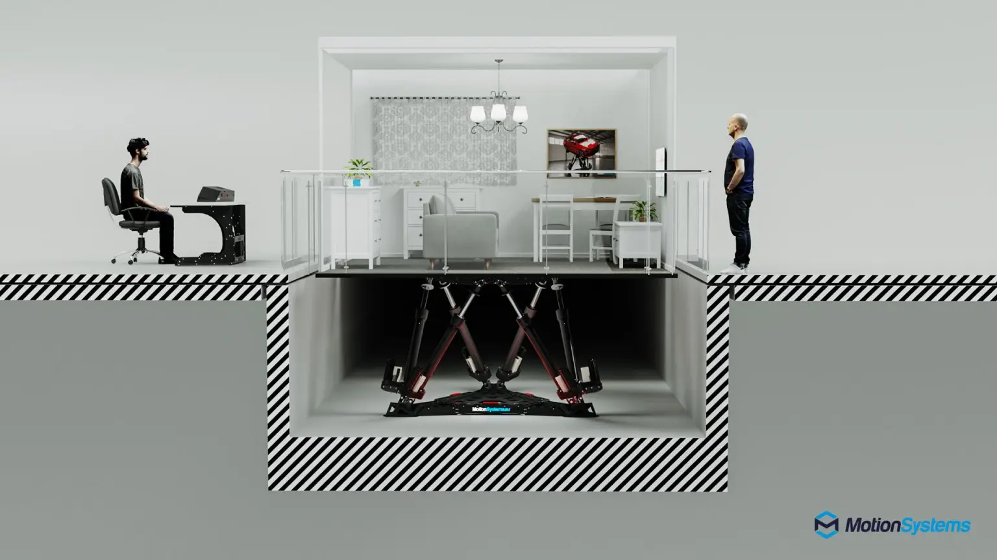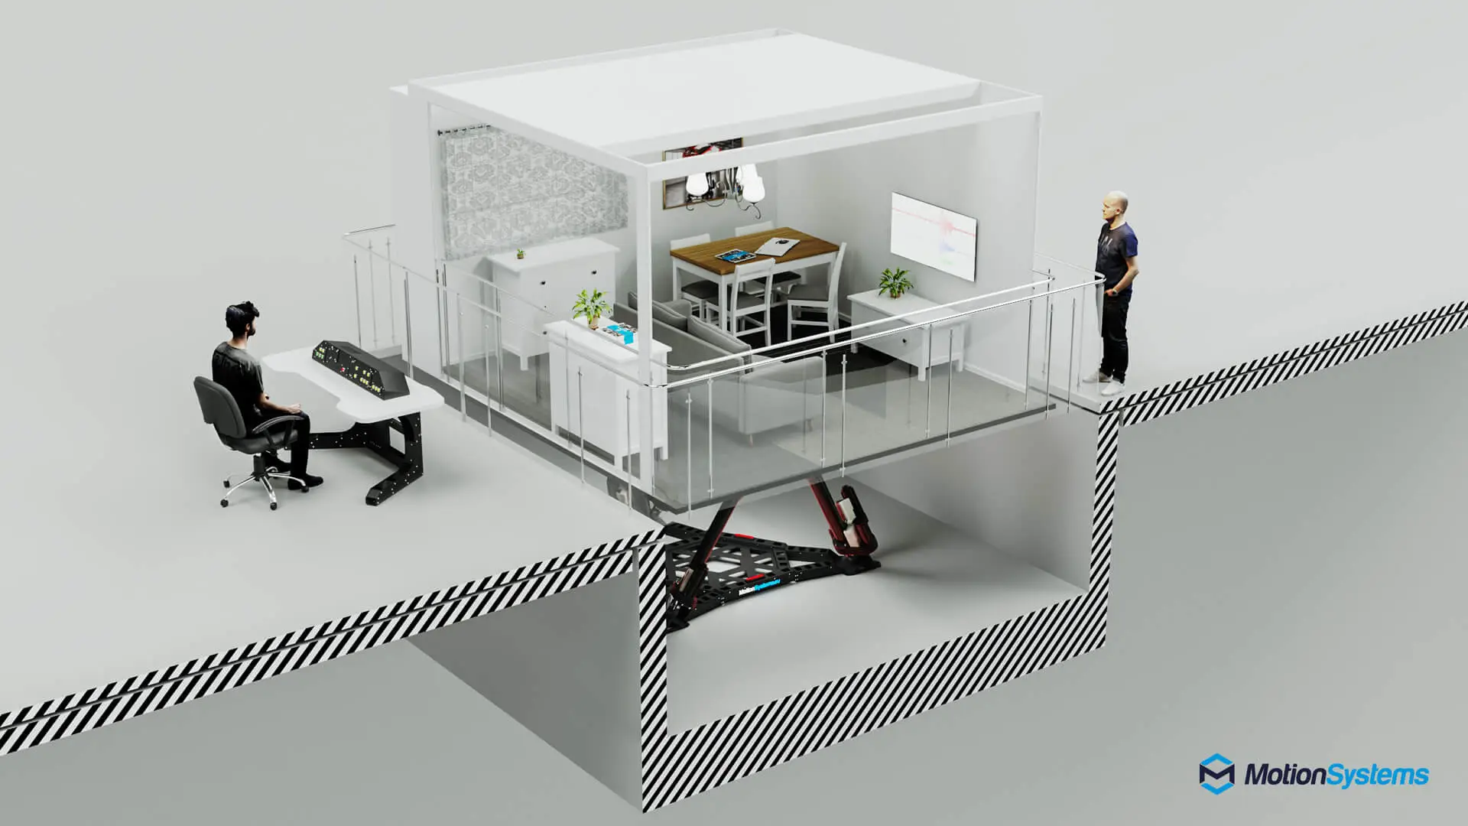

### **Conclusion**

This paper is aimed at evaluating how VR could enhance earthquake simulation to benefit different groups of people. The advantages were divided into four main parts which correlated to four main groups of people who benefit from the VR simulation technology. Ordinary people could utilize VR disaster simulation to learn seismic safety skills with a feeling of presence. Scientists can also conduct research during a virtual earthquake and engineers could directly view the constructional change during and after the earthquake. As for public sectors and insurance companies, VR simulated earthquakes could not only help them to draw people’s attention to earthquake safety but also could potentially improve their post-earthquake rescue and reconstruction skills. Therefore, this approach could potentially be used for earthquake knowledge exploration, seismic safety education and earthquake damage mitigation.

### **References**

Akinola, Y. M., Agbonifo, O. C., & Sarumi, O. A. (2020). Virtual Reality as a tool for learning: The past, present and the prospect*. Journal of Applied Learning & Teaching, 3*(2). https://doi.org/10.37074/jalt.2020.3.2.10

Fast-Berglund, Å., Gong, L., & Li, D. (2018). Testing and validating Extended Reality (xR) technologies in manufacturing*. Procedia Manufacturing, 25,* 31–38. https://doi.org/10.1016/j.promfg.2018.06.054

García, S., Trejo, P., & García, A. (2020). Virtual Reality-Neural Networks for reconstruction of devastated cities by earthquakes: Lacustrine deposits in Mexico City*. Procedia Manufacturing, 44,* 513–519. https://doi.org/10.1016/j.promfg.2020.02.261

Goltz, J. D., Park, H., Nakano, G., & Yamori, K. (2020). Earthquake ground motion and human behavior: Using DYFI data to assess behavioral response to earthquakes*. Earthquake Spectra, 36*(3), 1231–1253. https://doi.org/10.1177/8755293019899958

Great ShakeOut Earthquake Drills. (2021). *2020 Global Participant Totals.* https://www.shakeout.org/glb_participants.php?year=2020

Gwynne, S. M. V., Kuligowski, E. D., Boyce, K. E., Nilsson, D., Robbins, A. P., Lovreglio, R., Thomas, J. R., & Roy‐Poirier, A. (2019). Enhancing egress drills: Preparation and assessment of evacuee performance*. Fire and Materials, 43*(6), 613–631. https://doi.org/10.1002/fam.2448

Hutchinson, T. C., Kuester, F., Hsieh, T.-J., & Chadwick, R. (2005). A hybrid reality environment and its application to the study of earthquake engineering*. Virtual Reality, 9*(1), 17–33. https://doi.org/10.1007/s10055-005-0001-7

Johnson, V. A., Ronan, K. R., Johnston, D. M., & Peace, R. (2016). Improving the Impact and Implementation of Disaster Education: Programs for Children Through Theory-Based Evaluation*. Risk Analysis, 36*(11), 2120–2135. https://doi.org/10.1111/risa.12545

LaValle, S. M. (2020). *Virtual Reality.* Cambridge University Press. http://vr.cs.uiuc.edu/

Li, C., Liang, W., Quigley, C., Zhao, Y., & Yu, L.-F. (2017). Earthquake safety training through virtual drills*. IEEE Transactions on Visualization and Computer Graphics, 23*(4), 1275–1284. https://doi.org/10.1109/TVCG.2017.2656958

Liu, Z., Jacques, C. C., Szyniszewski, S., Guest, J. K., Schafer, B. W., Igusa, T., & Mitrani-Reiser, J. (2016). Agent-Based Simulation of Building Evacuation after an Earthquake: Coupling Human Behavior with Structural Response*. Natural Hazards Review, 17*(1), 04015019. https://doi.org/10.1061/(ASCE)NH.1527-6996.0000199

Lovreglio, R., Gonzalez, V., Feng, Z., Amor, R., Spearpoint, M., Thomas, J., Trotter, M., & Sacks, R. (2018). Prototyping virtual reality serious games for building earthquake preparedness: The Auckland City Hospital case study*. Advanced Engineering Informatics, 38,* 670–682. https://doi.org/10.1016/j.aei.2018.08.018

Lu, X., Yang, Z., Xu, Z., & Xiong, C. (2020). Scenario simulation of indoor post-earthquake fire rescue based on building information model and virtual reality*. Advances in Engineering Software, 143,* 102792. https://doi.org/10.1016/j.advengsoft.2020.102792

Mitsuhara, H., Tanimura, C., Nemoto, J., & Shishibori, M. (2019). Failure-enhanced evacuation training using a VR-based disaster simulator: A comparative experiment with simulated evacuees*. Procedia Computer Science, 159,* 1670–1679. https://doi.org/10.1016/j.procs.2019.09.337

Motion Systems. (n.d.). *When the Earth shakes...earthquake simulator.* Retrieved March 28, 2021, from https://motionsystems.eu/earthquake-simulator/

Oculus. (2018). *Earthquake Simulator VR* [Software]. https://www.oculus.com/experiences/rift/1708834312528485/

Patrick, J. (2011, June). Haiti earthquake response: Emerging evaluation lessons. *Evaluation Insights, 1*.

Peek-Asa, C., Kraus, J. F., Bourque, L. B., Vimalachandra, D., Yu, J., & Abrams, J. (1998). Fatal and hospitalized injuries resulting from the 1994 Northridge earthquake*. International Journal of Epidemiology, 27*(3), 459–465. https://doi.org/10.1093/ije/27.3.459

Perry, S., Cox, D., Jones, L., Bernknopf, R., Goltz, J., Hudnut, K., Mileti, D., Ponti, D., Porter, K., Reichle, M., Seligson, H., Shoaf, K., Treiman, J., & Wein, A. (2008). *The ShakeOut earthquake scenario: A story that Southern Californians are writing.* U.S. Geological Survey.https://doi.org/10.3133/cir1324

Pulevr. (n.d.). *华夏VR地震仪|地震平台|VR地震模拟体验|地震体验平台-普乐蛙官*. Retrieved March 14, 2021, from https://www.pulevr.com/product/54.html

Satriano, C., Wu, Y.-M., Zollo, A., & Kanamori, H. (2011). Earthquake early warning: Concepts, methods and physical grounds*. Soil Dynamics and Earthquake Engineering, 31*(2), 106–118. https://doi.org/10.1016/j.soildyn.2010.07.007

Setareh, M., Bowman, D. A., & Kalita, A. (2005). Development of a virtual reality structural analysis system*. Journal of Architectural Engineering, 11*(4), 156–164. https://doi.org/10.1061/(ASCE)1076-0431(2005)11:4(156)

Shudayfat, E., Moldoveanu, F., & Moldoveanu, A. (2012). A 3D virtual learning environment for teaching chemistry in high school. In *Annals of DAAAM for 2012 & Proceedings of the 23rd International DAAAM Symposium* (Vol. 23, No. 1, pp. 2304-1382).

Simpson, D. M. (2002). Earthquake drills and simulations in community-based training and preparedness programmes*. Disasters, 26*(1), 55–69. https://doi.org/10.1111/1467-7717.00191

Sinha, R., Sapre, A., Patil, A., Singhvi, A., Sathe, M., & Rathi, V. (2012). Earthquake disaster simulation in immersive 3d environment. In *Proceeding of the 15Th World Conference on Earthquake Engineering*. WCEE.

Snieder, R., van Eck, T., & van Eck, T. (1997). Earthquake prediction: A political problem? *Geologische Rundschau, 86*(2), 446–463. https://doi.org/10.1007/s005310050153

Suali, E., Juasin, N. S. I., Hamit, F. A. A., Anisuzzaman, S. M., & Asidin, M. A. (2020).Analysis of human factors and workloads in earthquake disaster evacuation simulations using virtual reality technology. *IOP Conference Series: Materials Science and Engineering, 1003*, 012082. https://doi.org/10.1088/1757-899X/1003/1/012082

Villaverde, R. (2009). *Fundamental Concepts of Earthquake Engineering.* CRC Press.

Vinnell, L. J., Wallis, A., Becker, J. S., & Johnston, D. M. (2020). Evaluating the ShakeOut drill in Aotearoa/New Zealand: Effects on knowledge, attitudes, and behaviour*. International Journal of Disaster Risk Reduction, 48,* 101721. https://doi.org/10.1016/j.ijdrr.2020.101721

Woo, G. (2010). Operational Earthquake Forecasting and Risk Management*. Seismological Research Letters, 81*(5), 778–782. https://doi.org/10.1785/gssrl.81.5.778

World Health Organization. (2017). *Economic losses, poverty & DISASTERS.* Retrieved from https://www.preventionweb.net/files/61119_credeconomiclosses.pdf

Xu, F., Chen, X., Ren, A., & Lu, X. (2008). Earthquake disaster simulation for an urban area, with GIS, CAD, FEA, and VR integration*. Tsinghua Science and Technology, 13*(S1), 311–316. https://doi.org/10.1016/S1007-0214(08)70167-6

Yang, X., Wu, Z., & Li, Y. (2011). Difference between real-life escape panic and mimic exercises in simulated situation with implications to the statistical physics models of emergency evacuation: The 2008 Wenchuan earthquake*. Physica A: Statistical Mechanics and Its Applications, 390*(12), 2375–2380. https://doi.org/10.1016/j.physa.2010.10.019

Zhu, Y., & Li, N. (2021). Virtual and augmented reality technologies for emergency management in the built environments: A state-of-the-art review*. Journal of Safety Science and Resilience, 2*(1), 1–10. https://doi.org/10.1016/j.jnlssr.2020.11.004